Binary Tree Traversal in Data Structure
The tree can be defined as a non-linear data structure that stores data in the form of nodes, and nodes are connected to each other with the help of edges. Among all the nodes, there is one main node called the root node, and all other nodes are the children of these nodes.
In any data structure, traversal is an important operation. In the traversal operation, we walk through the data structure visiting each element of the data structure at least once. The traversal operation plays a very important role while doing various other operations on the data structure like some of the operations are searching, in which we need to visit each element of the data structure at least once so that we can compare each incoming element from the data structure to the key that we want to find in the data structure. So like any other data structure, the tree data also needs to be traversed to access each element, also known as a node of the tree data structure.
There are different ways of traversing a tree depending upon the order in which the tree's nodes are visited and the types of data structure used for traversing the tree. There are various data structures involved in traversing a tree, as traversing a tree involves iterating over all nodes in some manner.
As from a given node, there could be more than one way to traverse or visit the next node of the tree, so it becomes important to store one of the nodes traverses further and store the rest of the nodes having a possible path for backtracking the tree if needed. Backtracking is not a linear approach, so we need different data structures for traversing through the whole tree. The stack and queue are the major data structure that is used for traversing a tree.
Traversal is a technique for visiting all of a tree's nodes and printing their values. Traversing a tree involves iterating over all nodes in some manner. We always start from the root (head) node since all nodes are connected by edges (links). As the tree is not a linear data structure, there can be more than one possible next node from a given node, so some nodes must be deferred, i.e., stored in some way for later visiting.

Implicit Array Representation of Binary Trees
A binary tree can be represented using a linked list and also using an array. Representation of this tree, using both(array and linked list) is explained below.
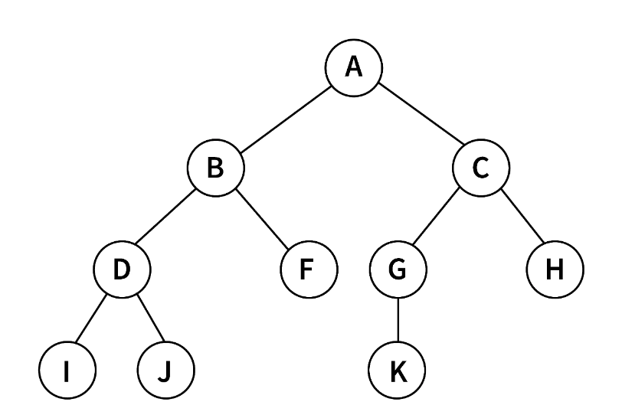

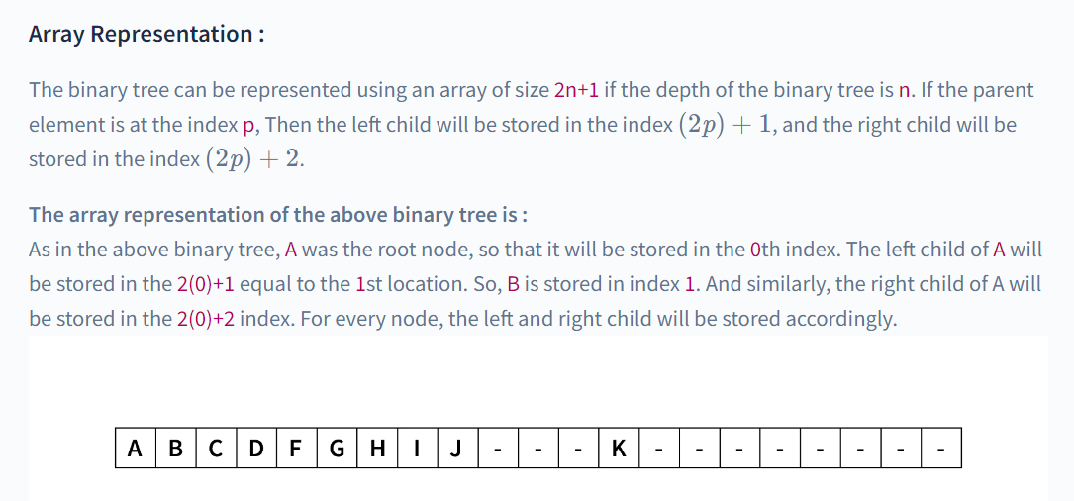
In the implicit array representation of binary trees, you use a one-dimensional array to represent a binary tree without using explicit pointers. The idea is to map the elements of the array to the nodes of the binary tree in a way that allows you to navigate through the tree efficiently.
Here's an example in C programming for creating and traversing a binary tree using an implicit array representation:
#include <stdio.h>

// Function to perform in-order traversal of the implicit array representation
void inOrderTraversal(int arr[], int n, int index) {
if (index < n) {
// Recur on the left subtree
inOrderTraversal(arr, n, 2 * index + 1);

// Process the current node
printf("%d ", arr[index]);

// Recur on the right subtree
inOrderTraversal(arr, n, 2 * index + 2);
printf(“%d”, arr[index]);
}
}

int main() {
// Example implicit array representing a binary tree
int arr[] = {1, 2, 3, 4, 5, 6, 7};

// Get the number of elements in the array
int n = sizeof(arr) / sizeof(arr[0]);

// Perform in-order traversal
printf("In-order traversal: ");
inOrderTraversal(arr, n, 0);
printf("\n");

return 0;
}

In this example, the implicit array is filled with elements such that if an element is at index i in the array, its left child is at index 2*i + 1 and its right child is at index 2*i + 2. This arrangement allows you to navigate through the binary tree without using explicit pointers.
The inOrderTraversal function performs an in-order traversal of the binary tree represented by the implicit array. You can adapt this approach for other types of tree traversals (pre-order, post-order, etc.) based on your requirements. Keep in mind that this method assumes a complete binary tree for simplicity. In a real-world scenario, you might need additional techniques to handle incomplete binary trees.

Types of Traversal of Binary Tree
There are three types of traversal of a binary tree.
- Inorder tree traversal
- Preorder tree traversal
- Postorder tree traversal

Inorder Tree Traversal
The left subtree is visited first, followed by the root, and finally the right subtree in this traversal strategy. Always keep in mind that any node might be a subtree in and of itself. The output of a binary tree traversal in order produces sorted key values in ascending order.
C Code
Let's write a basic C program for Inorder traversal of the binary search tree.
- //C Program for Inorder traversal of the binary search tree

- #include<stdio.h>
- #include<stdlib.h>

- struct node
- {
- int key;
- struct node *left;
- struct node *right;
- };

- //return a new node with the given value
- struct node *getNode(int val)
- {
- struct node *newNode;

- newNode = malloc(sizeof(struct node));

- newNode->key = val;
- newNode->left = NULL;
- newNode->right = NULL;

- return newNode;
- }

- //inserts nodes in the binary search tree
- struct node *insertNode(struct node *root, int val)
- {
- if(root == NULL)
- return getNode(val);

- if(root->key < val)
- root->right = insertNode(root->right,val);

- if(root->key > val)
- root->left = insertNode(root->left,val);

- return root;
- }

- //inorder traversal of the binary search tree
- void inorder(struct node *root)
- {
- if(root == NULL)
- return;

- //traverse the left subtree
- inorder(root->left);

- //visit the root
- printf("%d ",root->key);

- //traverse the right subtree
- inorder(root->right);
- Print(“%d”, root->key);
- }

- int main()
- {
- struct node *root = NULL;

- int data;
- char ch;
- /* Do while loop to display various options to select from to decide the input */
- do
- {
- printf("\nSelect one of the operations::");
- printf("\n1. To insert a new node in the Binary Tree");
- printf("\n2. To display the nodes of the Binary Tree(via Inorder Traversal).\n");

- int choice;
- scanf("%d",&choice);
- switch (choice)
- {
- case 1 :
- printf("\nEnter the value to be inserted\n");
- scanf("%d",&data);
- root = insertNode(root,data);
- break;
- case 2 :
- printf("\nInorder Traversal of the Binary Tree::\n");
- inorder(root);
- break;
- default :
- printf("Wrong Entry\n");
- break;
- }

- printf("\nDo you want to continue (Type y or n)\n");
- scanf(" %c",&ch);
- } while (ch == 'Y'|| ch == 'N');

- return 0;
- }
Output
The above C code hives the following output.
Select one of the operations::
1. To insert a new node in the Binary Tree
2. To display the nodes of the Binary Tree (via Inorder Traversal).
1

Enter the value to be inserted
12

Do you want to continue (Type y or n)
y

Select one of the operations::
1. To insert a new node in the Binary Tree
2. To display the nodes of the Binary Tree(via Inorder Traversal).
1

Enter the value to be inserted
98

Do you want to continue (Type y or n)
y

Select one of the operations::
1. To insert a new node in the Binary Tree
2. To display the nodes of the Binary Tree(via Inorder Traversal).
1

Enter the value to be inserted
23

Do you want to continue (Type y or n)
y

Select one of the operations::
1. To insert a new node in the Binary Tree
2. To display the nodes of the Binary Tree(via Inorder Traversal).
1

Enter the value to be inserted
78

Do you want to continue (Type y or n)
y

Select one of the operations::
1. To insert a new node in the Binary Tree
2. To display the nodes of the Binary Tree(via Inorder Traversal).
1

Enter the value to be inserted
45

Do you want to continue (Type y or n)
y

Select one of the operations::
1. To insert a new node in the Binary Tree
2. To display the nodes of the Binary Tree(via Inorder Traversal).
1

Enter the value to be inserted
87

Do you want to continue (Type y or n)
y

Select one of the operations::
1. To insert a new node in the Binary Tree
2. To display the nodes of the Binary Tree(via Inorder Traversal).
2

Inorder Traversal of the Binary Tree::
12 23 45 78 87 98
Do you want to continue (Type y or n)
n

Preorder Tree Traversal
In this traversal method, the root node is visited first, then the left subtree, and finally the right subtree.
Code
Let's write a C code for the Preorder traversal of the binary search tree.
- /*
- * Program: Preorder traversal of the binary search tree
- * Language: C
- */

- #include<stdio.h>
- #include<stdlib.h>

- struct node
- {
- int key;
- struct node *left;
- struct node *right;
- };

- //return a new node with the given value
- struct node *getNode(int val)
- {
- struct node *newNode;

- newNode = malloc(sizeof(struct node));

- newNode->key = val;
- newNode->left = NULL;
- newNode->right = NULL;

- return newNode;
- }

- //inserts nodes in the binary search tree
- struct node *insertNode(struct node *root, int val)
- {
- if(root == NULL)
- return getNode(val);

- if(root->key < val)
- root->right = insertNode(root->right,val);

- if(root->key > val)
- root->left = insertNode(root->left,val);

- return root;
- }

- //preorder traversal of the binary search tree
- void preorder(struct node *root)
- {
- if(root == NULL)
- return;

- //visit the root
- printf("%d ",root->key);

- //traverse the left subtree
- preorder(root->left);

- //traverse the right subtree
- preorder(root->right);
- }

- int main()
- {
- struct node *root = NULL;

- int data;
- char ch;
- /* Do while loop to display various options to select from to decide the input */
- do
- {
- printf("\nSelect one of the operations::");
- printf("\n1. To insert a new node in the Binary Tree");
- printf("\n2. To display the nodes of the Binary Tree(via Preorder Traversal).\n");

- int choice;
- scanf("%d",&choice);
- switch (choice)
- {
- case 1 :
- printf("\nEnter the value to be inserted\n");
- scanf("%d",&data);
- root = insertNode(root,data);
- break;
- case 2 :
- printf("\nPreorder Traversal of the Binary Tree::\n");
- preorder(root);
- break;
- default :
- printf("Wrong Entry\n");
- break;
- }

- printf("\nDo you want to continue (Type y or n)\n");
- scanf(" %c",&ch);
- } while (ch == 'Y'|| ch == 'N');

- return 0;
- }
Output:
Select one of the operations::
1. To insert a new node in the Binary Tree
2. To display the nodes of the Binary Tree(via Preorder Traversal).
1

Enter the value to be inserted
45

Do you want to continue (Type y or n)
y

Select one of the operations::
1. To insert a new node in the Binary Tree
2. To display the nodes of the Binary Tree(via Preorder Traversal).
1

Enter the value to be inserted
53

Do you want to continue (Type y or n)
y

Select one of the operations::
1. To insert a new node in the Binary Tree
2. To display the nodes of the Binary Tree(via Preorder Traversal).
1

Enter the value to be inserted
1

Do you want to continue (Type y or n)
y

Select one of the operations::
1. To insert a new node in the Binary Tree
2. To display the nodes of the Binary Tree(via Preorder Traversal).
1

Enter the value to be inserted
2

Do you want to continue (Type y or n)
y

Select one of the operations::
1. To insert a new node in the Binary Tree
2. To display the nodes of the Binary Tree(via Preorder Traversal).
1

Enter the value to be inserted
97

Do you want to continue (Type y or n)
y

Select one of the operations::
1. To insert a new node in the Binary Tree
2. To display the nodes of the Binary Tree(via Preorder Traversal).
1

Enter the value to be inserted
22

Do you want to continue (Type y or n)
y

Select one of the operations::
1. To insert a new node in the Binary Tree
2. To display the nodes of the Binary Tree(via Preorder Traversal).
2

Preorder Traversal of the Binary Tree::
45 1 2 22 53 97
Do you want to continue (Type y or n)
y

Select one of the operations::
1. To insert a new node in the Binary Tree
2. To display the nodes of the Binary Tree(via Preorder Traversal).
1

Enter the value to be inserted
76

Do you want to continue (Type y or n)
y

Select one of the operations::
1. To insert a new node in the Binary Tree
2. To display the nodes of the Binary Tree(via Preorder Traversal).
1

Enter the value to be inserted
30

Do you want to continue (Type y or n)
y

Select one of the operations::
1. To insert a new node in the Binary Tree
2. To display the nodes of the Binary Tree(via Preorder Traversal).
1

Enter the value to be inserted
67

Do you want to continue (Type y or n)
y

Select one of the operations::
1. To insert a new node in the Binary Tree
2. To display the nodes of the Binary Tree(via Preorder Traversal).
1

Enter the value to be inserted
4

Do you want to continue (Type y or n)
y

Select one of the operations::
1. To insert a new node in the Binary Tree
2. To display the nodes of the Binary Tree(via Preorder Traversal).
2

Preorder Traversal of the Binary Tree::
45 1 2 22 4 30 53 97 76 67
Do you want to continue (Type y or n)
n

Post order Tree Traversal
The root node is visited last in this traversal method, hence the name. First, we traverse the left subtree, then the right subtree, and finally the root node.
Code
Let's write a program for Postorder traversal of the binary search tree.
- /*
- * Program: Postorder traversal of the binary search tree
- * Language: C
- */

- #include<stdio.h>
- #include<stdlib.h>

- struct node
- {
- int key;
- struct node *left;
- struct node *right;
- };

- //return a new node with the given value
- struct node *getNode(int val)
- {
- struct node *newNode;

- newNode = malloc(sizeof(struct node));

- newNode->key = val;
- newNode->left = NULL;
- newNode->right = NULL;

- return newNode;
- }
- //inserts nodes in the binary search tree
- struct node *insertNode(struct node *root, int val)
- {
- if(root == NULL)
- return getNode(val);

- if(root->key < val)
- root->right = insertNode(root->right,val);

- if(root->key > val)
- root->left = insertNode(root->left,val);

- return root;
- }

- //postorder traversal of the binary search tree
- void postorder(struct node *root)
- {
- if(root == NULL)
- return;

- //traverse the left subtree
- postorder(root->left);

- //traverse the right subtree
- postorder(root->right);

- //visit the root
- printf("%d ",root->key);
- }
- int main()
- {
- struct node *root = NULL;

- int data;
- char ch;
- /* Do while loop to display various options to select from to decide the input */
- do
- {
- printf("\nSelect one of the operations::");
- printf("\n1. To insert a new node in the Binary Tree");
- printf("\n2. To display the nodes of the Binary Tree(via Postorder Traversal).\n");

- int choice;
- scanf("%d",&choice);
- switch (choice)
- {
- case 1 :
- printf("\nEnter the value to be inserted\n");
- scanf("%d",&data);
- root = insertNode(root,data);
- break;
- case 2 :
- printf("\nPostorder Traversal of the Binary Tree::\n");
- postorder(root);
- break;
- default :
- printf("Wrong Entry\n");
- break;
- }

- printf("\nDo you want to continue (Type y or n)\n");
- scanf(" %c",&ch);
- } while (ch == 'Y'|| ch == 'N');

- return 0;
- }
Output:
Select one of the operations::
1. To insert a new node in the Binary Tree
2. To display the nodes of the Binary Tree(via Postorder Traversal).
1

Enter the value to be inserted
12

Do you want to continue (Type y or n)
y

Select one of the operations::
1. To insert a new node in the Binary Tree
2. To display the nodes of the Binary Tree(via Postorder Traversal).
1

Enter the value to be inserted
31

Do you want to continue (Type y or n)
y

Select one of the operations::
1. To insert a new node in the Binary Tree
2. To display the nodes of the Binary Tree(via Postorder Traversal).
24
Wrong Entry

Do you want to continue (Type y or n)
y

Select one of the operations::
1. To insert a new node in the Binary Tree
2. To display the nodes of the Binary Tree(via Postorder Traversal).
1

Enter the value to be inserted
24

Do you want to continue (Type y or n)
y

Select one of the operations::
1. To insert a new node in the Binary Tree
2. To display the nodes of the Binary Tree(via Postorder Traversal).
1

Enter the value to be inserted
88

Do you want to continue (Type y or n)
y

Select one of the operations::
1. To insert a new node in the Binary Tree
2. To display the nodes of the Binary Tree(via Postorder Traversal).
1

Enter the value to be inserted
67

Do you want to continue (Type y or n)
y

Select one of the operations::
1. To insert a new node in the Binary Tree
2. To display the nodes of the Binary Tree(via Postorder Traversal).
1

Enter the value to be inserted
56

Do you want to continue (Type y or n)
y

Select one of the operations::
1. To insert a new node in the Binary Tree
2. To display the nodes of the Binary Tree(via Postorder Traversal).
1

Enter the value to be inserted
90

Do you want to continue (Type y or n)
y

Select one of the operations::
1. To insert a new node in the Binary Tree
2. To display the nodes of the Binary Tree(via Postorder Traversal).
1

Enter the value to be inserted
44

Do you want to continue (Type y or n)
y

Select one of the operations::
1. To insert a new node in the Binary Tree
2. To display the nodes of the Binary Tree(via Postorder Traversal).
1

Enter the value to be inserted
71

Do you want to continue (Type y or n)
y

Select one of the operations::
1. To insert a new node in the Binary Tree
2. To display the nodes of the Binary Tree(via Postorder Traversal).
1

Enter the value to be inserted
38

Do you want to continue (Type y or n)
y

Select one of the operations::
1. To insert a new node in the Binary Tree
2. To display the nodes of the Binary Tree(via Postorder Traversal).
1

Enter the value to be inserted
29

Do you want to continue (Type y or n)
y

Select one of the operations::
1. To insert a new node in the Binary Tree
2. To display the nodes of the Binary Tree(via Postorder Traversal).
2

Postorder Traversal of the Binary Tree::
29 24 38 44 56 71 67 90 88 31 12
Do you want to continue (Type y or n)
n
We have seen the different C programs to implement inorder, preorder, and postorder traversal of the nodes of the Binary tree. Now let us write a code to perform all three types of traversal in a single program.
Code
- //Binary tree traversal:

- #include <stdio.h>
- // #include <conio.h>
- #include <malloc.h>
- struct node
- {
- struct node *left;
- int data;
- struct node *right;
- };

- void main()
- {
- void insert(struct node **,int);
- void inorder(struct node *);
- void postorder(struct node *);
- void preorder(struct node *);

- struct node *ptr = NULL;
- int no,i,num;

- // ptr = NULL;
- // ptr->data=0;

- int data;
- char ch;
- /* Do while loop to display various options to select from to decide the input */
- do
- {
- printf("\nSelect one of the operations::");
- printf("\n1. To insert a new node in the Binary Tree");
- printf("\n2. To display the nodes of the Binary Tree(via Preorder Traversal).");
- printf("\n3. To display the nodes of the Binary Tree(via Inorder Traversal).");
- printf("\n4. To display the nodes of the Binary Tree(via Postorder Traversal).\n");

- int choice;
- scanf("%d",&choice);
- switch (choice)
- {
- case 1 :
- printf("\nEnter the value to be inserted\n");
- scanf("%d",&data);
- insert(&ptr,data);
- break;
- case 2 :
- printf("\nPreorder Traversal of the Binary Tree::\n");
- preorder(ptr);
- break;
- case 3 :
- printf("\nInorder Traversal of the Binary Tree::\n");
- inorder(ptr);
- break;
- case 4 :
- printf("\nPostorder Traversal of the Binary Tree::\n");
- postorder(ptr);
- break;
- default :
- printf("Wrong Entry\n");
- break;
- }

- printf("\nDo you want to continue (Type y or n)\n");
- scanf(" %c",&ch);
- } while (ch == 'Y'|| ch == 'y');

- // printf("\nProgram for Tree Traversal\n");
- // printf("Enter the number of nodes to add to the tree.<BR>\n");
- // scanf("%d",&no);

- // for(i=0;i<no;i++)
- // {
- // printf("Enter the item\n");
- // scanf("%d",&num);
- // insert(&ptr,num);
- // }

- // //getch();
- // printf("\nINORDER TRAVERSAL\n");
- // inorder(ptr);

- // printf("\nPREORDER TRAVERSAL\n");
- // preorder(ptr);

- // printf("\nPOSTORDER TRAVERSAL\n");
- // postorder(ptr);

- }

- void insert(struct node **p,int num)
- {
- if((*p)==NULL)
- {
- printf("Leaf node created.");
- (*p)=malloc(sizeof(struct node));
- (*p)->left = NULL;
- (*p)->right = NULL;
- (*p)->data = num;
- return;
- }
- else
- {
- if(num==(*p)->data)
- {
- printf("\nREPEATED ENTRY ERROR VALUE REJECTED\n");
- return;
- }
- if(num<(*p)->data)
- {
- printf("\nDirected to left link.\n");
- insert(&((*p)->left),num);
- }
- else
- {
- printf("Directed to right link.\n");
- insert(&((*p)->right),num);
- }
- }
- return;
- }

- void inorder(struct node *p)
- {
- if(p!=NULL)
- {
- inorder(p->left);
- printf("%d ",p->data);
- inorder(p->right);
- }
- else
- return;
- }

- void preorder(struct node *p)
- {
- if(p!=NULL)
- {
- printf("%d ",p->data);
- preorder(p->left);
- preorder(p->right);
- }
- else
- return;
- }

- void postorder(struct node *p)
- {
- if(p!=NULL)
- {
- postorder(p->left);
- postorder(p->right);
- printf("%d ",p->data);
- }
- else
- return;
- }
Output:
Select one of the operations::
1. To insert a new node in the Binary Tree
2. To display the nodes of the Binary Tree(via Preorder Traversal).
3. To display the nodes of the Binary Tree(via Inorder Traversal).
4. To display the nodes of the Binary Tree(via Postorder Traversal).
1

Enter the value to be inserted
2
Leaf node created.
Do you want to continue (Type y or n)
y

Select one of the operations::
1. To insert a new node in the Binary Tree
2. To display the nodes of the Binary Tree(via Preorder Traversal).
3. To display the nodes of the Binary Tree(via Inorder Traversal).
4. To display the nodes of the Binary Tree(via Postorder Traversal).
1

Enter the value to be inserted
5
Directed to right link.
Leaf node created.
Do you want to continue (Type y or n)
y

Select one of the operations::
1. To insert a new node in the Binary Tree
2. To display the nodes of the Binary Tree(via Preorder Traversal).
3. To display the nodes of the Binary Tree(via Inorder Traversal).
4. To display the nodes of the Binary Tree(via Postorder Traversal).
1

Enter the value to be inserted
7
Directed to right link.
Directed to right link.
Leaf node created.
Do you want to continue (Type y or n)
Y

Select one of the operations::
1. To insert a new node in the Binary Tree
2. To display the nodes of the Binary Tree(via Preorder Traversal).
3. To display the nodes of the Binary Tree(via Inorder Traversal).
4. To display the nodes of the Binary Tree(via Postorder Traversal).
1

Enter the value to be inserted
9
Directed to right link.
Directed to right link.
Directed to right link.
Leaf node created.
Do you want to continue (Type y or n)
y

Select one of the operations::
1. To insert a new node in the Binary Tree
2. To display the nodes of the Binary Tree(via Preorder Traversal).
3. To display the nodes of the Binary Tree(via Inorder Traversal).
4. To display the nodes of the Binary Tree(via Postorder Traversal).
1

Enter the value to be inserted
31
Directed to right link.
Directed to right link.
Directed to right link.
Directed to right link.
Leaf node created.
Do you want to continue (Type y or n)
y

Select one of the operations::
1. To insert a new node in the Binary Tree
2. To display the nodes of the Binary Tree(via Preorder Traversal).
3. To display the nodes of the Binary Tree(via Inorder Traversal).
4. To display the nodes of the Binary Tree(via Postorder Traversal).
1

Enter the value to be inserted
78
Directed to right link.
Directed to right link.
Directed to right link.
Directed to right link.
Directed to right link.
Leaf node created.
Do you want to continue (Type y or n)
y

Select one of the operations::
1. To insert a new node in the Binary Tree
2. To display the nodes of the Binary Tree(via Preorder Traversal).
3. To display the nodes of the Binary Tree(via Inorder Traversal).
4. To display the nodes of the Binary Tree(via Postorder Traversal).
2

Preorder Traversal of the Binary Tree::
2 5 7 9 31 78
Do you want to continue (Type y or n)
y

Select one of the operations::
1. To insert a new node in the Binary Tree
2. To display the nodes of the Binary Tree(via Preorder Traversal).
3. To display the nodes of the Binary Tree(via Inorder Traversal).
4. To display the nodes of the Binary Tree(via Postorder Traversal).
3

Inorder Traversal of the Binary Tree::
2 5 7 9 31 78
Do you want to continue (Type y or n)
y

Select one of the operations::
1. To insert a new node in the Binary Tree
2. To display the nodes of the Binary Tree(via Preorder Traversal).
3. To display the nodes of the Binary Tree(via Inorder Traversal).
4. To display the nodes of the Binary Tree(via Postorder Traversal).
4

Postorder Traversal of the Binary Tree::
78 31 9 7 5 2
Do you want to continue (Type y or n)
n

Threaded Binary Tree
In this article, we will understand about the threaded binary tree in detail.
What do you mean by Threaded Binary Tree?
In the linked representation of binary trees, more than one half of the link fields contain NULL values which results in wastage of storage space. If a binary tree consists of n nodes then n+1 link fields contain NULL values. So in order to effectively manage the space, a method was devised by Perlis and Thornton in which the NULL links are replaced with special links known as threads. Such binary trees with threads are known as threaded binary trees. Each node in a threaded binary tree either contains a link to its child node or thread to other nodes in the tree.
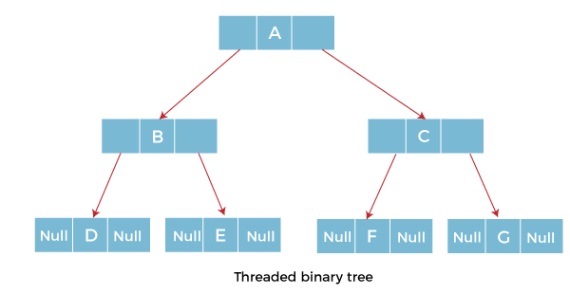

Types of Threaded Binary Tree
There are two types of threaded Binary Tree:
- One-way threaded Binary Tree
- Two-way threaded Binary Tree
One-way threaded Binary trees:
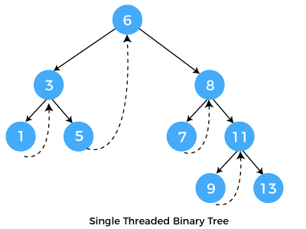
In one-way threaded binary trees, a thread will appear either in the right or left link field of a node. If it appears in the right link field of a node then it will point to the next node that will appear on performing in order traversal. Such trees are called Right threaded binary trees. If thread appears in the left field of a node then it will point to the nodes inorder predecessor. Such trees are called Left threaded binary trees. Left threaded binary trees are used less often as they don't yield the last advantages of right threaded binary trees. In one-way threaded binary trees, the right link field of last node and left link field of first node contains a NULL. In order to distinguish threads from normal links they are represented by dotted lines.
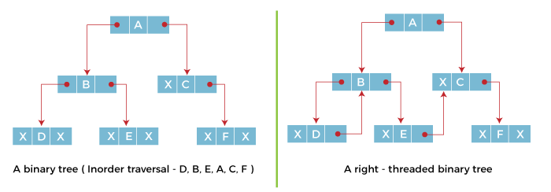
The above figure shows the inorder traversal of this binary tree yields D, B, E, A, C, F. When this tree is represented as a right threaded binary tree, the right link field of leaf node D which contains a NULL value is replaced with a thread that points to node B which is the inorder successor of a node D. In the same way other nodes containing values in the right link field will contain NULL value.
Two-way threaded Binary Trees:
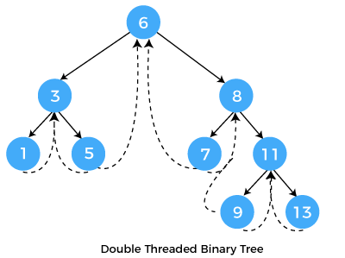
In two-way threaded Binary trees, the right link field of a node containing NULL values is replaced by a thread that points to nodes inorder successor and left field of a node containing NULL values is replaced by a thread that points to nodes inorder predecessor.
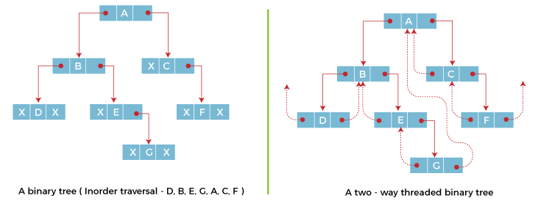
ADVERTISEMENT
The above figure shows the inorder traversal of this binary tree yields D, B, E, G, A, C, F. If we consider the two-way threaded Binary tree, the node E whose left field contains NULL is replaced by a thread pointing to its inorder predecessor i.e. node B. Similarly, for node G whose right and left linked fields contain NULL values are replaced by threads such that right link field points to its inorder successor and left link field points to its inorder predecessor. In the same way, other nodes containing NULL values in their link fields are filled with threads.
ADVERTISEMENT
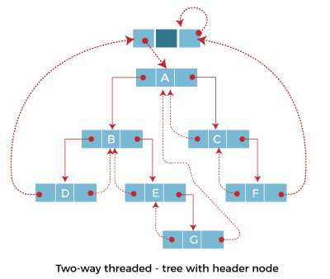
In the above figure of two-way threaded Binary tree, we noticed that no left thread is possible for the first node and no right thread is possible for the last node. This is because they don't have any inorder predecessor and successor respectively. This is indicated by threads pointing nowhere. So in order to maintain the uniformity of threads, we maintain a special node called the header node. The header node does not contain any data part and its left link field points to the root node and its right link field points to itself. If this header node is included in the two-way threaded Binary tree then this node becomes the inorder predecessor of the first node and inorder successor of the last node. Now threads of left link fields of the first node and right link fields of the last node will point to the header node.

Algorithm for Inorder Traversal of Threaded Binary Tree:
- ALgorithm Inorder(I)
- {
- ThreadedTreeNode *Header;
- Header=I;
- while(1)
- {
- I=fnFindInorder_Successor(H);
- if(I==Header)
- return;
- else
- print(I->info);
- }
- }
- In the above algorithm, we have discussed the Inorder traversal of Threaded binary trees.
- Pseudocode of Threaded Tree in C:
- #include <stdio.h>
- #include <stdlib.h>
- typedef enum {false,true} boolean;
- struct node *in_succ(struct node *p);
- struct node *in_pred(struct node *p);
- struct node *insert(struct node *root, int ikey);
- struct node *del(struct node *root, int dkey);
- struct node *case_a(struct node *root, struct node *par,struct node *ptr);
- struct node *case_b(struct node *root,struct node *par,struct node *ptr);
- struct node *case_c(struct node *root, struct node *par,struct node *ptr);
- void inorder( struct node *root);
- void preorder( struct node *root);

- struct node
- {
- struct node *left;
- boolean lthread;
- int info;
- boolean rthread;
- struct node *right;
- };
- int main( )
- {
- clrscr();
- int choice,num;
- struct node *root=NULL;
- while(1)
- {
- printf("\Program of Threaded Tree in C\n");
- printf("1.Insert\n");
- printf("2.Delete\n");
- printf("3.Inorder Traversal\n");
- printf("4.Preorder Traversal\n");
- printf("5.Quit\n");
- printf("\nEnter your choice : ");
- scanf("%d",&choice);
- switch(choice)
- {
- case 1:
- printf("\nEnter the number to be inserted : ");
- scanf("%d",&num);
- root = insert(root,num);
- break;
- case 2:
- printf("\nEnter the number to be deleted : ");
- scanf("%d",&num);
- root = del(root,num);
- break;
- case 3:
- inorder(root);
- break;
- case 4:
- preorder(root);
- break;
- case 5:
- exit(1);

- default:
- printf("\nWrong choice\n");
- }
- }
- return 0;
- }
- struct node *insert(struct node *root, int ikey)
- {
- struct node *tmp,*par,*ptr;
- int found=0;
- ptr = root;
- par = NULL;
- while( ptr!=NULL )
- {
- if( ikey == ptr->info)
- {
- found =1;
- break;
- }
- par = ptr;
- if(ikey < ptr->info)
- {
- if(ptr->lthread == false)
- ptr = ptr->left;
- else
- break;
- }
- else
- {
- if(ptr->rthread == false)
- ptr = ptr->right;
- else
- break;
- }
- }
- if(found)
- printf("\nDuplicate key");
- else
- {
- tmp=(struct node *)malloc(sizeof(struct node));
- tmp->info=ikey;
- tmp->lthread = true;
- tmp->rthread = true;
- if(par==NULL)
- {
- root=tmp;
- tmp->left=NULL;
- tmp->right=NULL;
- }
- else if( ikey < par->info )
- {
- tmp->left=par->left;
- tmp->right=par;
- par->lthread=false;
- par->left=tmp;
- }
- else
- {
- tmp->left=par;
- tmp->right=par->right;
- par->rthread=false;
- par->right=tmp;
- }
- }
- return root;
- }

- struct node *del(struct node *root, int dkey)
- {
- struct node *par,*ptr;
- int found=0;
- ptr = root;
- par = NULL;
- while( ptr!=NULL)
- {
- if( dkey == ptr->info)
- {
- found =1;
- break;
- }
- par = ptr;
- if(dkey < ptr->info)
- {
- if(ptr->lthread == false)
- ptr = ptr->left;
- else
- break;
- }
- else
- {
- if(ptr->rthread == false)
- ptr = ptr->right;
- else
- break;
- }
- }
- if(found==0)
- printf("\ndkey not present in tree");
- else if(ptr->lthread==false && ptr->rthread==false)/*2 children*/
- root = case_c(root,par,ptr);
- else if(ptr->lthread==false )
- root = case_b(root, par,ptr);
- else if(ptr->rthread==false)
- root = case_b(root, par,ptr);
- else
- root = case_a(root,par,ptr);
- return root;
- }

- struct node *case_a(struct node *root, struct node *par,struct node *ptr )
- {
- if(par==NULL)
- root=NULL;
- else if(ptr==par->left)
- {
- par->lthread=true;
- par->left=ptr->left;
- }
- else
- {
- par->rthread=true;
- par->right=ptr->right;
- }
- free(ptr);
- return root;
- }
- struct node *case_b(struct node *root,struct node *par,struct node *ptr)
- {
- struct node *child,*s,*p;
- if(ptr->lthread==false)
- child=ptr->left;
- else
- child=ptr->right;
- if(par==NULL )
- root=child;
- else if( ptr==par->left)
- par->left=child;
- else
- par->right=child;
- s=in_succ(ptr);
- p=in_pred(ptr);
- if(ptr->lthread==false)
- p->right=s;
- else
- {
- if(ptr->rthread==false)
- s->left=p;
- }
- free(ptr);
- return root;
- }
- struct node *case_c(struct node *root, struct node *par,struct node *ptr)
- {
- struct node *succ,*parsucc;
- parsucc = ptr;
- succ = ptr->right;
- while(succ->left!=NULL)
- {
- parsucc = succ;
- succ = succ->left;
- }
- ptr->info = succ->info;
- if(succ->lthread==true && succ->rthread==true)
- root = case_a(root, parsucc,succ);
- else
- root = case_b(root, parsucc,succ);
- return root;
- }
- struct node *in_succ(struct node *ptr)
- {
- if(ptr->rthread==true)
- return ptr->right;
- else
- {
- ptr=ptr->right;
- while(ptr->lthread==false)
- ptr=ptr->left;
- return ptr;
- }
- }
- struct node *in_pred(struct node *ptr)
- {
- if(ptr->lthread==true)
- return ptr->left;
- else
- {
- ptr=ptr->left;
- while(ptr->rthread==false)
- ptr=ptr->right;
- return ptr;
- }
- }
- void inorder( struct node *root)
- {
- struct node *ptr;
- if(root == NULL )
- {
- printf("Tree is empty");
- return;
- }
- ptr=root;
- while(ptr->lthread==false)
- ptr=ptr->left;
- while( ptr!=NULL )
- {
- printf("%d ",ptr->info);
- ptr=in_succ(ptr);
- }
- }
- void preorder(struct node *root )
- {
- struct node *ptr;
- if(root==NULL)
- {
- printf("Tree is empty");
- return;
- }
- ptr=root;
- while(ptr!=NULL)
- {
- printf("%d ",ptr->info);
- if(ptr->lthread==false)
- ptr=ptr->left;
- else if(ptr->rthread==false)
- ptr=ptr->right;
- else
- {
- while(ptr!=NULL && ptr->rthread==true)
- ptr=ptr->right;
- if(ptr!=NULL)
- ptr=ptr->right;
- }
- }
- }
Explanation:
In the above example, we have created a threaded binary tree for various operations.

Output:
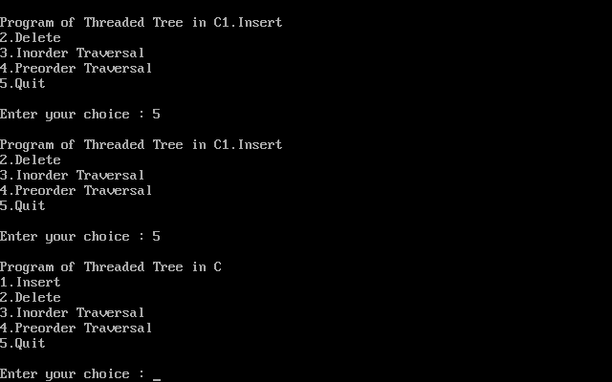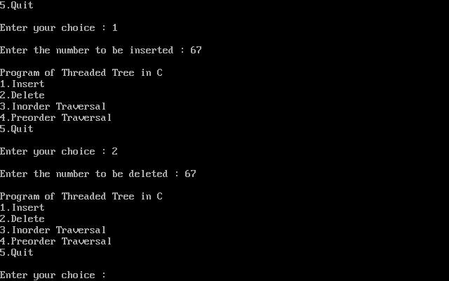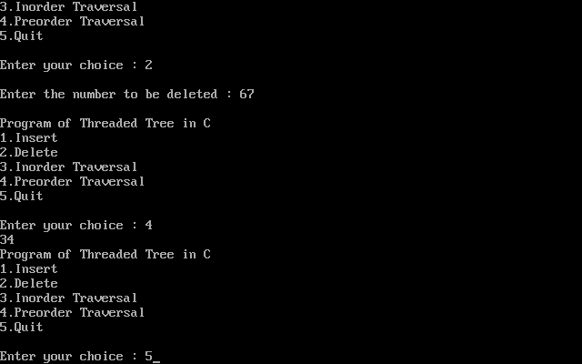
Advantages of Threaded Binary Tree:
- In threaded binary tree, linear and fast traversal of nodes in the tree so there is no requirement of stack. If the stack is used then it consumes a lot of memory and time.
- It is more general as one can efficiently determine the successor and predecessor of any node by simply following the thread and links. It almost behaves like a circular linked list.
Disadvantages of Threaded Binary Tree:
- When implemented, the threaded binary tree needs to maintain the extra information for each node to indicate whether the link field of each node points to an ordinary node or the node's successor and predecessor.
- Insertion into and deletion from a threaded binary tree are more time consuming since both threads and ordinary links need to be maintained.

